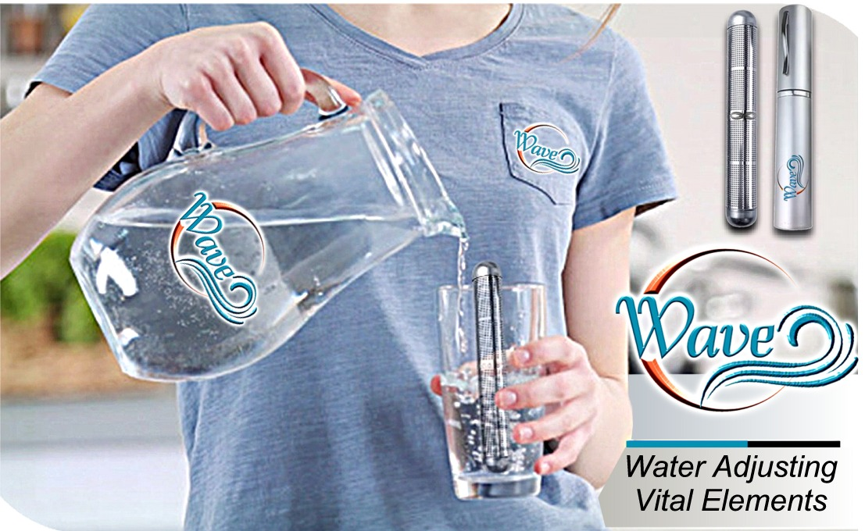
Many studies from Scientist, Doctors and Researchers show that 75% of Americans are Chronically Dehydrated and the other 25% show 3 or more signs of Dehydration.

The Signs and Symptoms of Dehydration

This seems simple just drink bottled, tap or well water! Right?
Well…
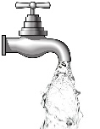
Tap Water has been shown to contain heavy metals, additives, chlorination by-products, pesticides, arsenic, radon and rocket fuel to name a few. Water may also travel through decaying pipes that may be eroding and leaching harmful chemicals into the water long before it reaches your kitchen. Yikes!

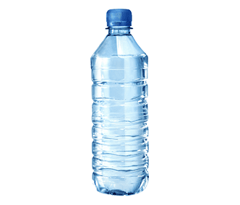
Bottled Water, which is often a purified version of a municipal water supply, and purified tap water are deplete of the minerals, such as fluoride, calcium, and magnesium.
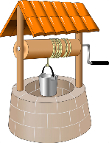
Well Water groundwater that fills wells can sometimes become contaminated by man-made products such as gasoline, oil, road salts, and chemicals, although the deeper the well, the less likely it is to be ridden with bad things. Ground water can pick up elements from the rock when it passes through.

Introducing The All-in-One Solution

A Portable Hydrogen Rich Micro Clustered Frequency Infused Re-Mineralized
Filtered Magnetized Alkaline Energized PH Balanced Structured Water.

Let me explain the Technology and Health Benefits that makes up the Wave.

Germanium
Germanium is a mineral that is believed to have various health benefits due to its physiological activities. Germanium might help the prevention of different cancers and other diseases by killing bacteria toxic to our organism. Germanium might also act against inflammation, increase blood circulation to the brain, support the immune system, and act as an antioxidant. Germanium might also help with blood pressure, anxiety, depression, arthritis, poisoning, and eyesight problems.
Negative Ion
Negative ions are molecules or atoms that have more electrons than protons. They are believed to have various health benefits, such as:
· Improving mood, circadian rhythm and mental alertness
· Enhancing recovery from physical exertion and reducing stress expelling foreign matter from the respiratory system and combating allergies and asthma.
· Increasing oxygen flow to the brain and cells
· Speeding up oxidation of serotonin in the blood, which affects mood and stress.

Far Infrared
Some recent good quality experimental and clinical scientific studies show Far-Infrared expands capillaries which... Improve blood circulation and skin complexion.
Strengthens cardiovascular system.. Far-Infrared is excellent for detoxification and helps lymphatic drainage. Wound healing.
Hydrogen
Hydrogen water benefits include improving mood, weight loss, blood sugar regulation, cancer prevention, eye health, arthritis relief, oral health, skin protection, muscle fatigue reduction, brain protection, lifespan prolongation, pH balance, wound healing, vitality, allergy remedy, cardiovascular and cerebrovascular health, athletic performance, hydration, and kidney function. Hydrogen water is purified water that is infused with excess molecular hydrogen, which is an antioxidant that can fight inflammation and oxidative damage. Hydrogen water is more thirst-quenching and filtered for safety. Hydrogen water is widely used by athletes and has undergone clinical research and scientific evidence.
Alkaline
An alkaline body is a body that has a pH above seven, which is slightly higher than the neutral pH of 7.35 Some sources claim that an alkaline body is a healthy body that prevents or fights off any kind of disease, including cancer. Others explain that an alkaline body is attained from foods that are easy to metabolize and provide energy. You can test your body’s pH by doing a urine test or using a pH strip in your mouth.
Zinc Stone
Zinc is a vital mineral that your body uses in countless ways. In fact, zinc is the second-most abundant trace mineral in your body — after iron — and is present in every cell. Zinc is necessary for the activity of over 300 enzymes that aid in metabolism, digestion & nerve function. In addition, it’s critical for the development and function of immune cells. This mineral is also fundamental to skin health, DNA synthesis, and protein production). What’s more, body growth and development rely on zinc because of its role in cell growth and division. Zinc is also needed for your senses of taste and smell. Because one of the enzymes crucial for proper taste and smell is dependent on this nutrient, a zinc deficiency can reduce your ability to taste or smell.

Frequencies
By drinking the Frequency Infused Water, which has a memory and is encoded with 204 different balanced harmonic frequency’s that are than transferred to your body. Energizing and tuning your body back closer to it’s original state.

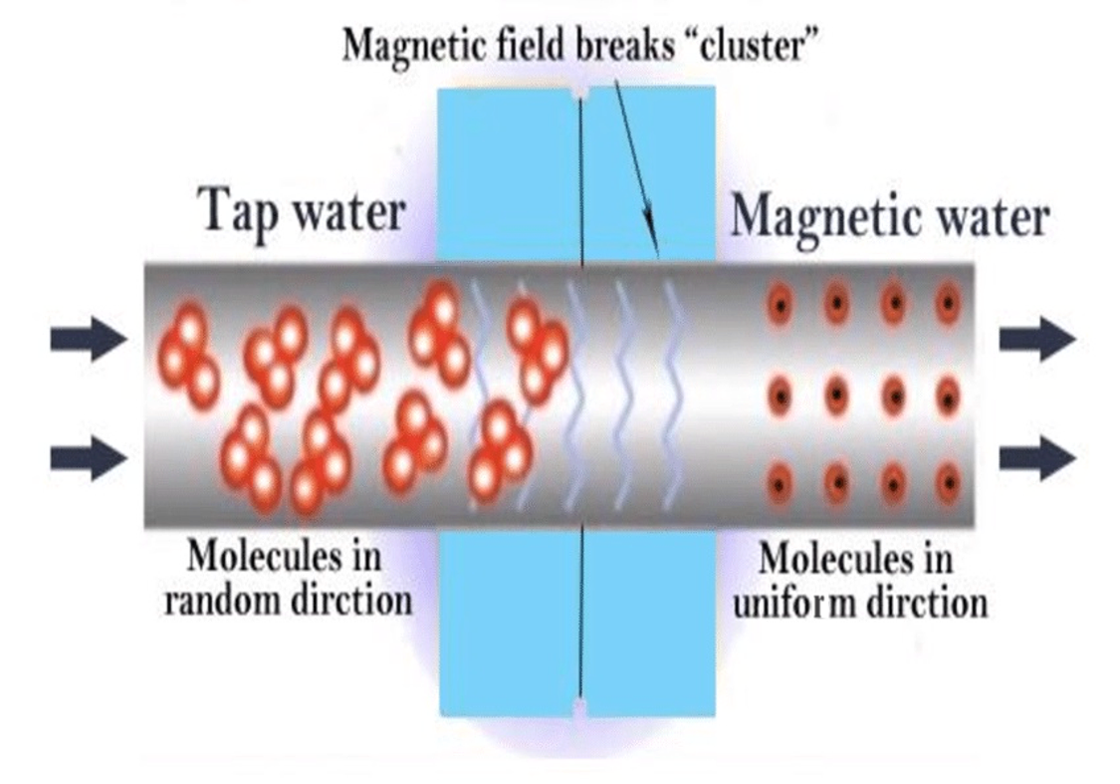
Magnetized Water Health Benefits

1. Prevents Aging And Fatigue
There is evidence stating that magnetic water helps “prevent aging and fatigue”. Now, how does it do this? Simple. It helps “increase the cell membrane permeability” (Ebrahim & Azab, 2017).
2. Helps Set Circulatory System In Rhythm
Magnetic water “helps unclog cholesterol and salts” from our “arteries and veins”, thereby helping to “normalize” our “circulatory systems” (Ebrahim & Azab, 2017).
3. Improves Metabolism
Magnetic water helps in controlling weight, in addition to maintaining proper diet. In this case, magnetic water “improves metabolic activity”, therefore, “it may be helpful in burning up excessive fatty tissue” found in our bodies (Ebrahim & Azab, 2017).
4. All-Around Alleviator
This water was also found to be extremely “effective in alleviating colds, coughs, bronchitis, all types of fever, arthritis pain, reducing blood pressure,” and aided in helping people quickly “recover” from a stroke (Ebrahim & Azab, 2017). Additionally, it also helped to regulate the period cycles of women who had been suffering from irregular periods .

5. Destroys Kidney Stones
This water also managed to destroy kidney stones by “breaking up kidney and gallbladder stones into small particles.” It “prevented further formation of stones in the kidneys and gallbladder” (Ebrahim & Azab, 2017). Wow, sounds pretty amazing, doesn’t it? For many of you, if it is your first time, hearing about Magnetic Water, and if you have never seen those two words used together, this concept probably really intrigued you! It’s no doubt that we want to know more about magnetic water, but before we get into that, let’s quickly go over those benefits this water offers, only so that you can sound like an expert on Magnetic water the next time you talk to your friend!


To review, Magnetic Water certainly has lots of prominent people supporting its benefits, and this is definitely making me want to try magnetic water out for myself! Here are the 5 Amazing Health Benefits once again: magnetic water prevents ageing and fatigue, helps set our circulatory system in rhythm, greatly improves our metabolism, works as an all-around alleviator, and last but not least, also destroys those perky and unbearable kidney stones! Wow! Sign me up, am I right? And with that said, I think I’ll leave you all as you try out the Magnetic Water for yourselves, and experience the wondrous health benefits it can offer you!
There was less diabetic kidney damage with magnetized water consumption. In addition, blood sugar was reduced and antioxidant defenses were increased. Cholesterol and triglyceride levels were almost normalized with magnetized water treatment.
A study comparing magnetized water to normal water in an oral water pick found that magnetized water reduced tartar 64% more effectively than standard water (Johnson 1998). Other studies used magnetized water as a mouth rinse.
Because magnetized water is wetter and therefore more penetrating, it furthers better assimilation of the various nutrients and vitamins in the cells
In his book "Magnets For Your Health" Dr. Louis Donnet, M.D., wrote, "magnetized water can be helpful in weight control, as an adjutant to a correct diet." He states (page 82) that he has seen over 100 successful cases. Because this water improves metabolic activity, it may be helpful in burning up excessive fatty tissue.
The Magnetic Effect" that he and his co-workers found they could overcome the early afternoon letdown by drinking a glass of magnetized water while relaxing for a few minutes. It also acts as a waste disposal agent for all living beings. Crops grow faster and stronger, flowers and plants are healthier and more resistant to disease;
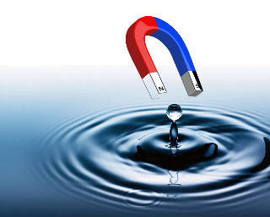
Bio-magnetism works in the human body through the circulatory system, the nervous system and the endocrine system. Magnetism is continuously penetrating every known particle, right down to the atom. Its ordering effect on living systems arises from the fact that magnetism is a blueprint of life itself. All known energies have as a base this electromagnetic field. The latest research indicates that magnetism has a very significant biological effect on human beings and is confirmed by the research of Dr. Robert Becker in his book "The Body Electric."
Dr. H.L. Bansel points out that magnetism increases the electrical conductivity of the blood. A weak current runs through it and the quantity of ions are increased. The newly ionized blood circulating throughout the body can significantly contribute to the efficiency of the blood flow as well as having a stabilizing effect on both high and low blood pressure.
Dr. Linus Pauling received his 1954 Nobel Prize for his discovery of the magnetic properties of blood. Blood contains ferrous hemoglobin (iron) that functions as a carrier of oxygen and carbon dioxide. As the blood circulates in the lung, fully magnetized ferrous hemoglobin is able to transport more oxygen to cell tissue as well as taking more carbon dioxide waste from the cell back to the lungs for removal. This means more energy and less fatigue as tissue cells and internal organs stay substantially healthier.

Bio-magnetism works to regulate and normalize hormone secretion in the glands. It is currently believed that the increased electrical current being produced forms like a net around the glands and secretory duct. An extra concentration of oxygen stimulates production while the electrical net regulates optimum secretion. As a result, conditions caused by a lack of hormone secretion or a hormone imbalance are through normalizing the hormone functions within the body. Hormones play an extremely important
role in rejuvenation and in general energy levels while proper circulation ensures that the hormone level is evenly distributed to all parts of the body. When magnetic flux passes through tissue, a secondary current is created around the flux lines in the tissue cells. This function of the cell becomes strengthened as the cell; metabolism responds to the bioelectrical currents initiated by the magnetic flux. This current induces muscle spasms to reduce and the activated cell metabolism lowers inflammation in the tissue. The increase of cellular metabolism aids in the regeneration and re-growth of cells.
The negative pole energies of magnetism interfere with the nerve cells ability to send pain impulses to the brain where the pain is registered. Blood cells have potassium in their centers which have a positive bioelectric charge. The nerve cell differs in an opposite way. During a pain response the outside switches to potassium with a positive bioelectric charge. Through attraction, the negative pole charge of a magnet creates a "blend off" of the potassium's positive bioelectric as the natural flow of current toward the negative pole.
Magnetized water tastes sweeter and has more clarity.
- Magnetic water promotes a more alkaline pH in the body
- Magnetic water promotes healing of wounds and burns
- Magnetic water has a therapeutic effect on digestive, nervous and urinary systems
- Magnetic water may also be beneficial for fevers, sore throat, menstrual and menopause discomfort.
- Magnetic water revitalizes the body
- Magnetic water provides positive effect on the autonomic nervous system
- Magnetized water has been reported to help regulate the heart function and clear clogged arteries
- Magnetic water has been beneficial for kidney ailments, gout, obesity and premature aging
- Magnetic water may help relieve pain
- Magnetic water infuses energy into the body, controls bacteria, and stimulates brain function.
Micro-Clustered Water
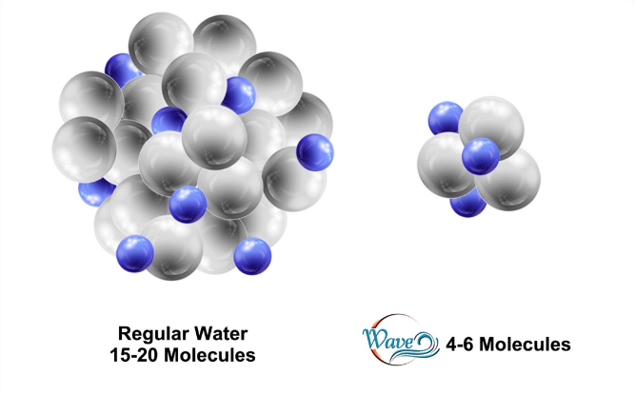
Water molecules are identified as h2o, two hydrogen atoms and one oxygen atom. But these molecules cluster together to form a water cluster. When water is piped, chemically treated and ‘de-natured’, water molecules tend to clump together into larger water clusters.
Tap water usually has water clusters with around 14-16 molecules. Sometimes water will cluster into as many as 30 – 40 molecules. This makes it very hard for the body to absorb as the body recognizes that it needs digesting, sorting and sifting.


Health Benefits

Did you know Wave water has a higher pH level than that of plain tap water. So proponents say that it can neutralize acid in your bloodstream. Some say that alkaline water can help prevent disease, such as cancer and heart disease. However, more research is needed to verify these claims.

Wave water has a higher pH (8 or 9) than regular water. It contains many essential minerals that help treat many ailments. It may counter the acidity in your body and may aid in diabetes treatment, boost bone health, regulate blood pressure, reduce body weight, act against cancer cells, and treat acid reflux.

What happens when you drink 9.5 pH water?
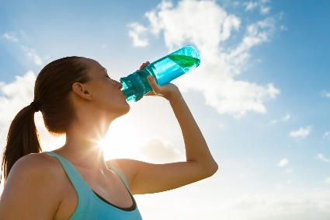
Boosts Immunity. Since alkaline water has a higher pH level than normal water, it can typically help with the acidity that builds up within the body. As your body continues to be affected by stress and poor diet, it can sometimes really put a damper on your immune system and its ability to work well.
According to Dr. Bulsiewicz, there's no doubt that some people who have acid-related digestive issues (with conditions like gastritis, peptic ulcer disease, or gastroesophageal reflux) may feel better when they drink alkaline water.
Can I take vitamins with Wave water?
If you take a multi-vitamin or specific vitamins and minerals to support your health, you might be able to get more from your supplements by taking them with ionized alkaline water
Does Wave water help with muscle pain?
Muscle cramps are a product of too much lactic acid buildup. Lactic acid is a byproduct of the muscle breaking down glucose when there is no oxygen left to be brokendown. Wave water delivers more oxygen to the muscles preventing this process from occurring.

Does Wave water kill parasites?
Since parasites can't live in an environment that is between 7.2 and 7.4 pH, alkalizing your diet will help remove them from your system.
Is Wave water good for nerves?
Wave water contains four major minerals that contribute to its remarkable health benefits: Calcium: Important for bone health, as well as heart, muscle, and nerve function.

Dehydration a major cause of Neurological Diseases
We've all experienced occasional dehydration. After a challenging workout or a battle with
illness, we've tried to rehydrate by tempering our thirst. Dehydration, however, can have effects beyond just being lethargic and irritable. According to recent research, there may be a direct connection between neurological disease development and extreme dehydration. Even those with dementia were found to have severe dehydration, according to autopsies. The size of the brain had also shrunk. Wave Water may help with Parkinson’s and Alzheimer’s Diseases

How can Wave Water help?
Wave water has exceptional hydration benefits in addition to having a great taste and strengthening the immune system. Your body will be less likely to become dehydrated if it receives the right amounts of hydrogen and oxygen. The brain, tissues, cells, and organs can all function at their best when the body is properly hydrated. Alkaline water will stimulate and increase the blood's supply of oxygen, which is essential for mental endurance and clarity. Because of alkaline water's neuroprotective properties, your brain and nervous system will have a stronger defense against illness. Alkaline water will stimulate and increase the blood's supply of oxygen, which is essential for mental endurance and clarity. Because of alkaline water's neuroprotective properties, your brain and nervous system will have a stronger defense against illness.

Is Wave water good for mental health?

Overall, alkaline water can be a helpful option in managing feelings of anxiety. By helping to balance pH levels, reduce inflammation, and provide essential nutrients and electrolytes, alkaline water can help to reduce symptoms of anxiety and promote better mental health.


Is Wave Water safe for pets?

Yes, alkaline water is perfectly safe for pets as long as they aren't using it to ingest medicine, taking alkaline water immediately before and after their meal, or while they're being nursed.


Can I Use Wave Water for my plants?
Yes, It can raise the pH level of the soil and help improve the absorption of nutrients. Additionally, Wave water is a natural way to improve plant growth.

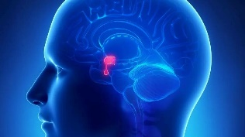
The Pineal Gland & Alkaline Ionized Water

When I drink alkaline ionized water, I often notice that I feel a distinct mental clarity and feeling of calm-satisfaction. No regular water has ever given me such a feeling of well-being. Others have had similar experiences. This sensation has been explained by Dr. Mona Harrison. [Dr. Mona Harrison was Chief Medical Officer of the DC Hosp, Assistant Dean of the BU School of Medicine, and Director of the International Water Council.]

Here is a quote “Alkaline ionized water is the frequency of the pineal gland and thus affects all other glands below the pineal gland. That is why the water can lower blood pressure and blood sugar, shrink an enlarged prostrate, stimulate sex drive, improve vision, improve MS and Parkinson’s Disease, just to name a few.”

According to Dr. Mona Harrison, Alzheimer’s patients, who have drunk about a gallon of ionized water a day, have experienced relief from their condition and children with ADD (Attention Deficit Disorder) have been calmed by drinking ionized water.

1. Regulates the pH balance
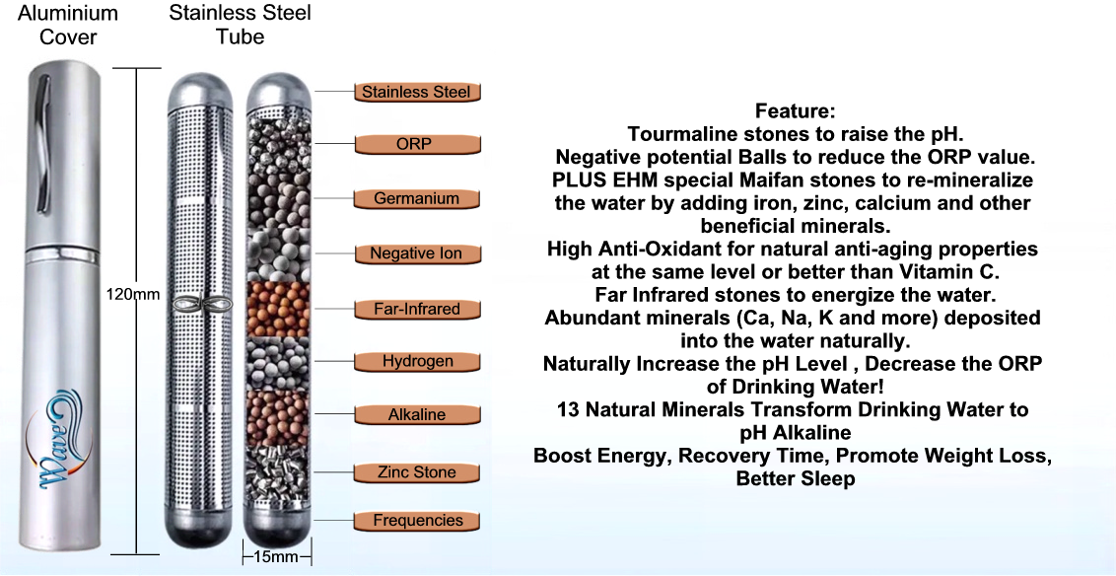
2. Reduces blood lipids and blood pressure
3. Regulates the gastrointestinal function
4. Promoting human metabolism
5. High dissolving power of the alkaline water
6. Protects the liver from harmful effects of alcohol and nicotine.
7. Powerful Anti-Oxidant: ORP reading of below -200mV in about 3-5 minutes
8. For better absorption of nutrients and minerals through reverse osmosis, oxygenating the body and increasing metabolic rate.

This sounds complicated and time consuming, right?
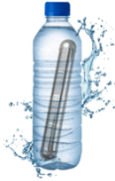
Not complicated at all, Just fill a 16 ounce bottle of water, drop the WAVE in, and shake vigorously for 30 seconds and wait 15-20 minutes before drinking.

And even our pets and plants can benefit from it.

Wave, the first all in one Portable Hydrogen Rich Micro Clustered Frequency Infused Re-Mineralized Filtered Magnetized Alkaline Energized PH Balanced Structured Water unit, the size of a fountain pen, fits in your pocket or purse. Good for 1 year…..only $20!

Turn your water into Wave Water

Catch the Wave to Health, Fitness and Longevity

