How to Identify Vietnam Currency?

Vietnamese Polymer Notes

500,000 VND Polymer Note
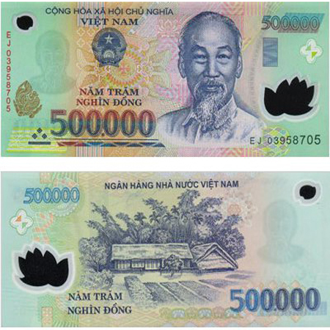

200,000 VND Polymer Note
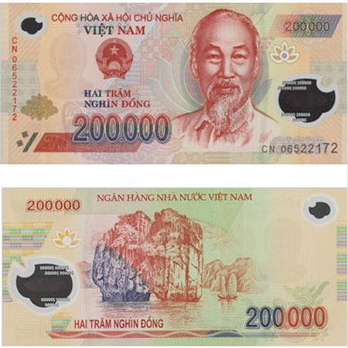

100,000 VND Polymer Note
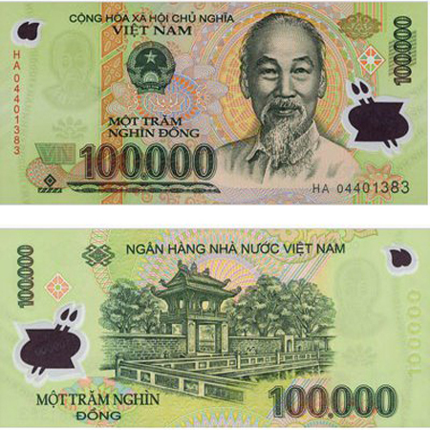

50,000 VND Polymer Note

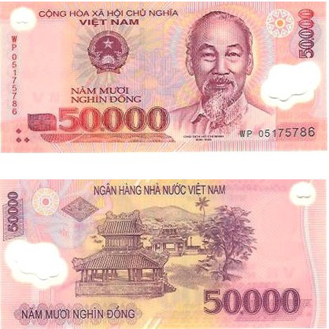

20,000 VND Polymer Note

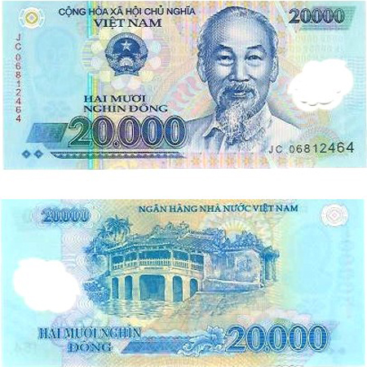

10,000 VND Polymer Note
